**EUMedRail and IPA workshop in Belgrade**

**14Feb**2019

From the 12th to the 14th of February, the EU Agency for Railways together with the Directorate for Railways in Serbia (National Safety Authority) held a workshop on Safety Management System and Safety Culture at the Chamber of Commerce and Industry of Serbia, in Belgrade.

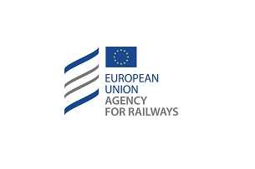

The workshop discussed the experience of the Infrastructure Manager and Railway Operators in the development, implementation and monitoring of Safety Management Systems, including the integration of human and organisational factors. In this context, experts in different domains presented some case studies and analysed them together in order to identify and share best practices.

Several EU representatives introduced the concept of Safety Culture and the EU Agency for Railways presented the European Railway Safety Culture Declaration that will be promoted in the framework of the EUMedRail and IPA projects.

The seminar concluded with a technical visit to the Serbian passenger operator, Srbija Voz.

More than 70 participants from the Southern Mediterranean area, Balkan region and EU representatives attended the event.